## Merchant

Demo date: Sep 12, 2024  
Scoping start date: Sep 12, 2024

MSA Signature Date: Sep 18, 2024  
Onboarding Kick Off Date: Sep 23, 2024

[If Exists] Opt Out Date: Mar 18, 2025  
Go Live Date: Oct 1, 2024

GTM POC: Nick  
Implementation POC: Ariel

ERP: QBO

Tax Integration: Other [Complyt](https://complyt.io/) through QBO

### 

### Key people at Merchant

### Accountant: Bookkeeper

### CFO: [Meyrav Thurston](https://www.linkedin.com/in/meyrav-thurston-674814143/), Head of US Finance and Operations

### Customer service rep who is really involved: Meyrav

* Account Receivable POC: Meyrav
* Billing POC: Meyrav

### 

| Notes Sections [Ops International Team to Ignore] *(AE/ Implementation to fill)*   * Info on how merchant bills   + Monthly, ~35 clients, bill for storage fees and # of pages processed per month.   + All usage billing and receives an excel for each client from their R&D team to populate invoices   Is there any important merchant relationship information?  1) What is the merchant temperament?  Great relationship. Straight shooter, amicable to working through things. Very nice and leading a horse to water type 2) Is there a key POC: (i.e.: who is the buyer/decision maker?)  Meyrav is head of finance. Has a bookkeeper working under her 3) What are the Tabs features that the key POC cares about?  Billing and invoice scheduling. Usage Data upload. Reporting. |
| --- |

### 

### Company summary *(AE to fill)*

[DigitalOwl](https://www.digitalowl.com/) is revolutionizing the way medical records are reviewed. Our proprietary AI-powered platform is specifically designed for medical records, allowing us to analyze and extract data quickly and accurately.

Our solution eliminates the need for manual review, freeing up your talented resources to focus on more critical activities. With DigitalOwl, you can harness the power of data and empower your team to make more informed decisions.

Our platform organizes data chronologically, making it easy to search and filter by medical condition, date, body system and more. This enables users to understand a complete medical history within a fraction of the time it would take to manually review hundreds of pages.

Say goodbye to the time-consuming, tedious, and error-prone process of manual medical record review. With DigitalOwl, you can significantly reduce the time and expense associated with this process, and gain access to meaningful, actionable insights in a fraction of the time.

Goals (North star)  
*(AE/ Implementation to fill)*

What is the merchant's goal? What pain are we solving? Why are they buying Tabs?

* Automating invoicing/billing and managing contracts is the biggest pain we are solving for. QBO users who were thinking about moving to NetSuite. Using Tabs to delay the decision

Is there an opt out clause? If so, what is the merchant looking for so they do not exercise it?

* Opt out at the 6 month mark (March 18, 2025). CEO would not sign without an opt out. Automating usage billing will be key to them not exercising

### Billing model *(AE/ Implementation to fill)*

* Are there unique things about the customer creation process for this merchant?

Monthly billing with usage data for # of pages processed in arrears

* Information on how merchant bills

Monthly in arrears

* How contract is broken up

N/A

* One off things to know about the merchant

N/A

### Contract Processing Steps *(Implementation/Success to fill)*

New event types + names of BTs:

* View = pages+PDF
* Connect = data, case-level data
  + This will be per case
  + Need a differentiator between data file and API
* Triage = PIA, post-issue audit
* Storage = storage (RGA example)
* Chat = chat

MIB - only one charged by case?

1. Steps to process
   1. Invoices date should be the 10th of the month
      1. Ex: Oct 10 invoice will be the Sep usage
   2. For Early Termination fees - make sure this is picked up, it shouldn't be a flat price
      1. This is what they want: Tabs to store the amount, and they have a way to invoke it on the invoice
      2. What I proposed: we have a unit price product where price = the amount, and quantity will either be 0 or 1
         * They will send it to us like usage where 1 means that to invoke the early termination
         * Dates will be the date specified for early termination
   3. Usage
      1. Processed as it is laid out on the table in the contract (examples below)
      2. There can be multiple usage BTs, some of which can be tiered:
         * Processing fee / pages per month / processing fee per pages + PDF
           1. This item is inclusive of anything in the contract that says pages and PDF. On the newer contracts, it will be more common for the contract to only have one or the other, but on the old contracts (and I suspect this will trickle into the newer ones for a while) there might be two separate listings for ‘pages’ and ‘PDF’. If this is the case, combine them into a single item and add the prices. (2 examples are below)
           2. Event type: VIEW
           3. Item name: VIEW
           4. Always tiered
         * Data, case-level data (example below)
           1. This might show as added % to each tier of BT

If so, duplicate the tiered BT and calculate the % noted for each tier.

The price for each tier should be the % added, not the total amount

* + - * 1. Event type: CONNECT
        2. Item name: CONNECT
        3. Sometimes tiered
      * Post-audit report / Post-issue audit / PIA
        1. Event type: TRIAGE
        2. Item name: TRIAGE
        3. Sometimes tiered
      * Advanced Analysis / Case Notes
        1. Event type: CASE NOTES
        2. Item name: CASE NOTES
        3. Unit
      * Chat
        1. Event type: CHAT
        2. Item name: CHAT
        3. Unit
      * Storage
        1. Event type: STORAGE
        2. Item name: STORAGE
        3. Unit

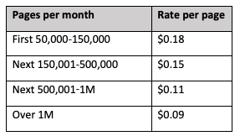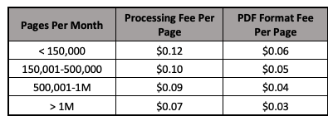

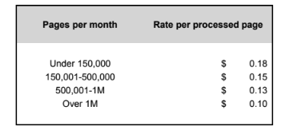

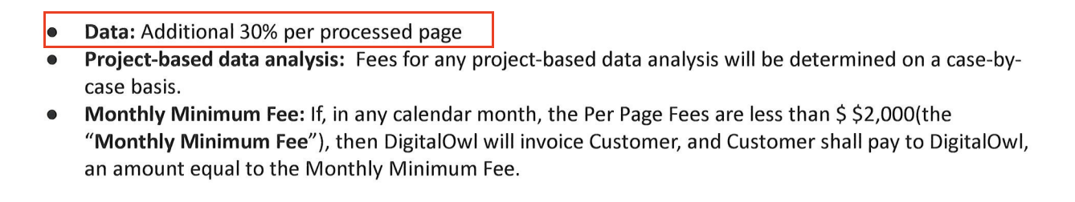

* + 1. Processing rules
       - All Usage BTs **In Arrears**
       - The start date of the first usage BT should be the 1st of the month that the contract started
         1. Ex: Start date Feb 15, Usage BTs start Feb 1.
       - Frequency should then be 1 extra month than the months accounted for in the rev schedule in order to account for the last month’s usage (only if the date on the contract isn’t the 1st of the month)
       - Integration items: **SaaS** for all
    2. MINIMUMS
       - Most contracts have a monthly minimum - this should be processed via the Usage AI tab on the contract page
       - Processing instructions:
         1. Has use requirements = true
         2. Apply usage models sequentially = false keep default state)
         3. Type = Minimum
         4. Usage name = Minimum monthly requirement
         5. Included products = select all USAGE BTs in the dropdown
         6. Minimum period = individual billing period
         7. Minimum amount = Amount specified in the contract

Be sure this is set to $ instead of #, which is the default state

* + - * 1. Integration item = SaaS
        2. Service period - there are 3 scenarios

**1 minimum**: If there is only 1 minimum listed, select “Service period same as contract” and the date picker will disable

**Tiered minimums**: However sometimes there can be an escalating minimum based on dates (For example, 5k for the first 6 months and then 7k for next 6 months, and then 9k for the rest of the contract, example below).

In this case, multiple usage models will be needed. For the first one, select the dates that the first minimum applies to.

Then, add a new model, with the same terms, but the service period will be the next set of dates that minimum applies to. Nothing that the contract will often say “first 3 months” so start/end dates of each minimum period will need to be deduced from that

**Pilot period:** The last option is that some contracts have a pilot period where they do not charge them the minimum for a set period of time. In this situation, create 1 minimum with the service period starting once the pilot period has ended

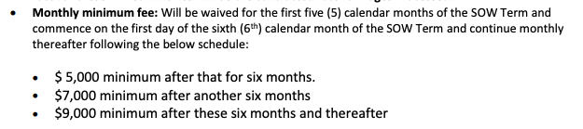

* + 1. Amendments - can be executed to update any of the following terms:
       - Minimum
         1. End the service dates on the previously processed minimum on the original contract Usage AI section, and then add a new usage model to reflect the new minimum with the applicable service dates

Sometimes the new minimum does not go into effect until the future

* + - * 1. If an amendment comes through with a new business line being added, the minimum for the new business line should be ***added*** to the original amount

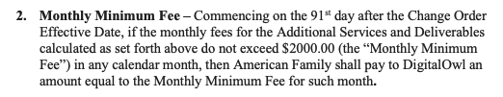

* + - * Pricing
        1. Update pricing
      * Service Term
        1. Extend or terminate service term on original BTs from the original contract
  1. There might be early termination fees in the contract (image below)
     1. Process them as BTs dated for the first day of the period they can terminate. [An example if Liferoc, please follow this as a guide](https://garage.tabsplatform.com/prod/contracts/1668271d-e4e3-4875-8252-66663307392b/terms/key).

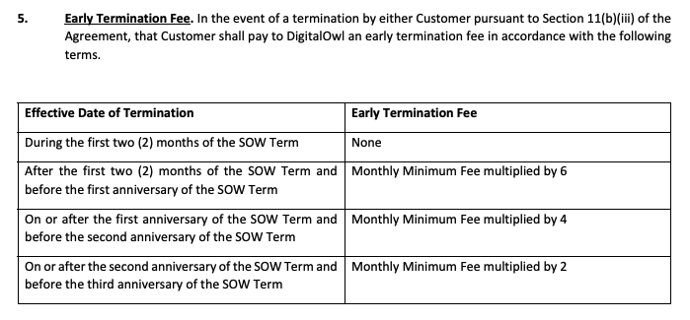

**BPOS TO IGNORE THIS SECTION**

***Ariel to check with merchant on this item***

1. Product line - add a product line to a current deal. The example below adds a line called “DUA summaries” to the contract. A few things should happen here:
   1. There might be a new product set added*(This is not happened much yet, but there might be 1 few instances of this in an amendment)*
   2. The existing tiered BTs should be duplicated, with the same pricing and term, but title is “DUA summaries” and revenue/period starts when amendment starts
   3. Event types that should be used should match that segment but for the new vertical:
      1. Pages - DUA
      2. PDF - DUA
      3. Summary - DUA
      4. Post audit report - DUA
2. USAGE AI Processing

* Amendments
  + if added min is updated, add old min and min together
  + Add new set of the tiered BTs that are the same as the other set, but with the new vertical added
  + Example: [American Family](https://garage.tabsplatform.com/prod/contracts/d7a99322-2a1e-4246-9c57-22c086de62e8/usage)
    - Added DUA Summaries for amendments
    - Min went from 1000 to 3000 (added 2000 in amendment)
    - Add new set tiered BTs but event type is the same + DUA

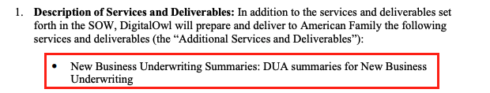

* 1. Dates nuances (International team to ignore for now)
     1. Invoices technically need to be on the 10th of every month, but the period is the entirety of the month before
        + Implementation: process all contracts as normal per the instructions above, and [Ariel Bernstein](mailto:abernstein@tabsplatform.com) will make the adjustments
        + Net new: Once a new contract is processed, let [Ashni Walia](mailto:awalia@tabsplatform.com) know and she will request the date adjustment

1. Specifics processing things the merchant has requested that may differ by contract (e.g. always back-date invoice date to final day of the month)
2. Default Service Term
   1. If None Listed, Ops Default is 1 Year
3. Default Net Payment Terms
   1. If None, Ops Default is 0
4. Default Billing Frequency
   1. If None Listed, Ops Default is Monthly
5. How do we handle taxes as a line item?
   1. If None Listed, Ops Default is every tax line item becomes a BT

### Events Processing (if necessary) *(Implementation/Success to fill)*

* Any important information on events billing

Integration Items Processing (if necessary)  
*(Implementation/Success to fill)*

* SaaS for all

Post Processing Communications (if necessary)  
*(Implementation/Success to fill)*

* Does the Ops Team need to notify anyone on the team re: completion of processing batches in Implementation or Active phase?
* Who needs to be notified and when?
  + Example:
    - Who: Customer Success [Azmat Aziz] needs to be notified
    - Where: Messari internal merchant channel
    - When: contracts are processed [Merchant Phase: Active]

### Customer Information *(Implementation/Success to fill)*

* Any important information on specifics customers of this merchant
  + Special memo’s certain invoices require
  + Invoice changes due to merchant/customer relationship

### Feature Requests *(AE/Implementation/Success to fill)*

* FR 1
  + What is it
  + Why it's important
  + Urgency

### Rewatch Calls *(AE/Implementation/Success to fill)*

* Disco and Demo - 9/12/24
  + <https://tabs.rewatch.com/video/605lyp08yzzlkb77-meyrav-thhurston-and-nicholas-gatti-september-12-2024>
* Sync on commercials - 9/16/24
  + <https://tabs.rewatch.com/video/t84eo50jc53nitt9-meyrav-nick-sync-september-16-2024>

**Appendix (OLD MIS requirements, archived)**

* + 1. Sometimes (on older contracts) the extra products will be in paragraph form. This can be processed a a few different ways:
       - Statement Fee states that it is waived for 6 months and then added back on. In this case, process another unit priced BT at .09 cents starting 6 months into the contract.

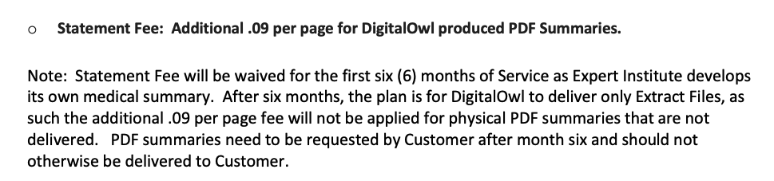

* + - * Statement fee is not waived for a specific duration, and it just stated in the terms below the table. In this case, do not process the extra .05 cents, as it is included in the pricing in the table.



* + - * **If there is another case where this exists but is not covered in the instruction above, please flag to** [**Ashni Walia**](mailto:awalia@tabsplatform.com)